**工商业储能**

**INDUSTRIAL AND COMMERCIAL ENERGY STORAGE**

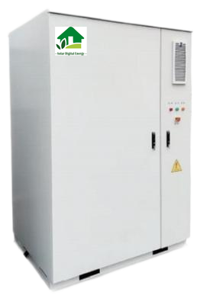

工商业储能一体柜

Industrial and commercial energy

storage integrated cabinet

应用领域APPLICATION FIELDS

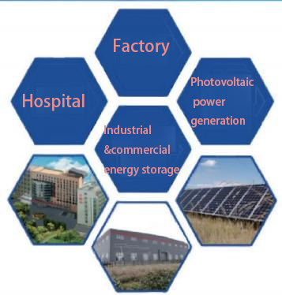

The energy storage system provides users with peak valley arbitrage mode and stable power quality management.

The product is mainly used in large-scale industrial, commercial, and residential fields, and has been extended to emerging applications such as communication base station backup power, UPS backup power, island micro-grids, and intelligent charging stations for photovoltaic storage and inspection. It helps to achieve electricity coverage in areas without power grids, reduce social electricity costs, improve electricity security on the electricity side, and maximize energy utilization to achieve social and economic benefits.

|  |  |
| --- | --- |
| **项目Item** | **标** **准**  **Standard** |
| 型号 Model | 户用储能-01 Household energy storage-01 |
| 电池容量Battery capacity | 280Ah |
| 电池类型Battery type | 磷酸铁锂Lithium iron phosphate |
| 标称电压Nominal voltage | DC768V |
| 电压范围Voltage range | DC600V-864V |
| 标称能量Nominal energy | 215KWh |
| 防护等级Protection level | IP54 |
| 电芯均衡Cell equalization | 主动均衡Active equalization |
| 额定充放电倍率Rated charge discharge rate | ≤0.5P |
| 组合方式Combination method | 5*1P48S |
| 工作温度Working temperature | -30℃--55℃ |
| 消 防 喷 剂 Fire spray | 七氟丙烷/全氟已酮Heptafluoropropane/Perfluorohexane |
| 认证方式Authentication method | 人脸识别/二维码/C卡/密码Facial recognition/QR code/IC card/password |
| 主要材质Main materials | 镀锌钢板Galvanized steel sheet |
| 表面涂层Surface coating | 静电喷涂/氟碳漆Electrostatic spraying/fluorocarbon paint |
| 温控方式 Temperature control method | 风冷Air cooling |
| 消防检测Fire detection | 温度/烟雾/明火/可燃气体Temperature/Smoke/Open Flame/Combustible Gas |